**PHYTHON DJANGO INTERNSHIP REPORT**

**Personal Details**

Name : Vaghela Akshay Ashokkumar

College : Shree Swaminarayan Institute of Technology

Degree : BE

Sem : 7

Github URL : https://github.com/Akshay2763/Akshay2763.git

**Company Details**

Company Name : Akash Technolabs

External Guide : Akash Padhiyar

Training Duration : 26/05/2021 to 21/06/2021

**Index**

|  |  |  |
| --- | --- | --- |
| **Index** | **Task detail** | **Page name** |
| 1 | Calculate average of 5 numbers | 1 to 2 |
| 2 | Check whethe number is even or odd. | 3 to 5 |
| 3 | Take a year and check whether is leap year or not. | 6 to 7 |
| 4 | Take a number and check whether is zero,negative or positvie. | 8 to 10 |
| 5 | Take 2 numbers and and display greatest number. | 11 to 12 |
| 6 | Take a number and find factorial of that number. | 13 to 14 |
| 7 | Write a program to swap numbers using third variable. | 15 to 16 |
| 8 | Take 2 numbers and find smallest number. | 17 |
| 9 | Take a number check if a number is less than 100 or not.if it is less than 100 than check if it is even or odd. | 18 to 19 |
| 10 | Take a number to print the square of a number if it is less than 10. | 20 |
| 11 | Take a number and check whether it is zero,positive or negative using nested IF...ELSE statement. | 21 to 23 |
| 12 | Take 3 numbers and find greatest number using nested IF..ELSE statement. | 24 to 25 |
| 13 | Take 3 numbers and find smallest number using logical operator. | 26 to 27 |
| 14 | Write a program to swap 2 numbers without taking third variable. | 28 to 29 |
| 15 | Take starting number and ending number from the user and print following series.  30  27  24  21  18  15  12  9  6  3  0 | 30 to 31 |

**Program 1**

a=int(input("enter first number"))

b=int(input("enter second number"))

c=int(input("enter third number"))

d=int(input("enter fourth number"))

e=int(input("enter fifth number"))

sum=a+b+c+d+e

print("sum is",sum)

average=sum/5

print("average is",average)

M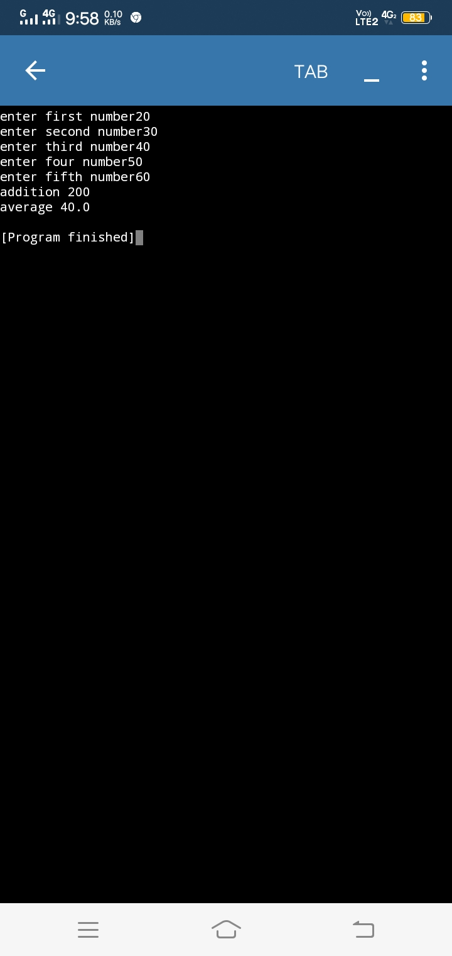

**program** **2**

n=int(input("Enter n:"))

if(n%2==0):

print(n,"n is even number")

else:

print(n,"n is odd number")

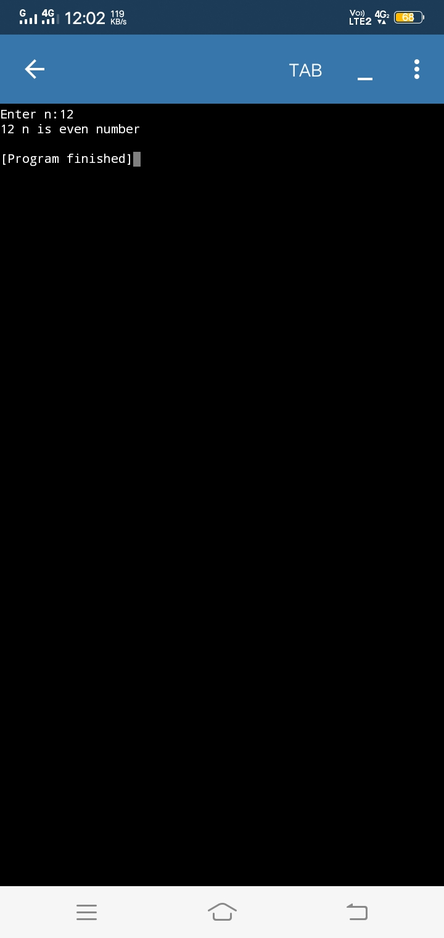

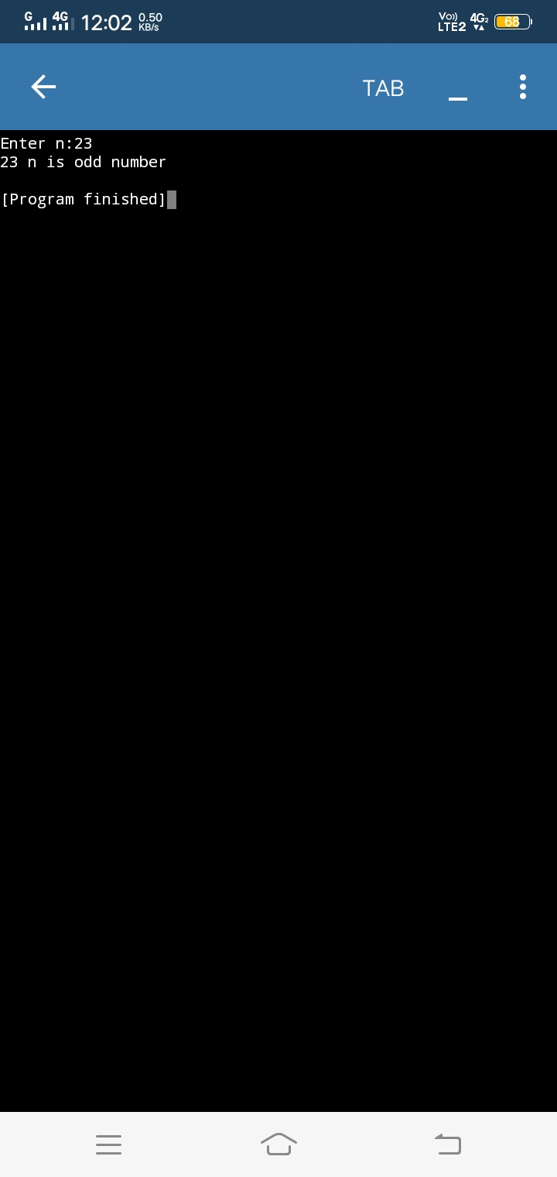

**Program 3**

year = int(input("enter the year "))

if (year % 400 == 0):

print(year,"is leap year")

elif (year % 4 == 0 and year % 100 != 0):

prinr(year,"is leap year")

else:

print(year,"is not leap year")

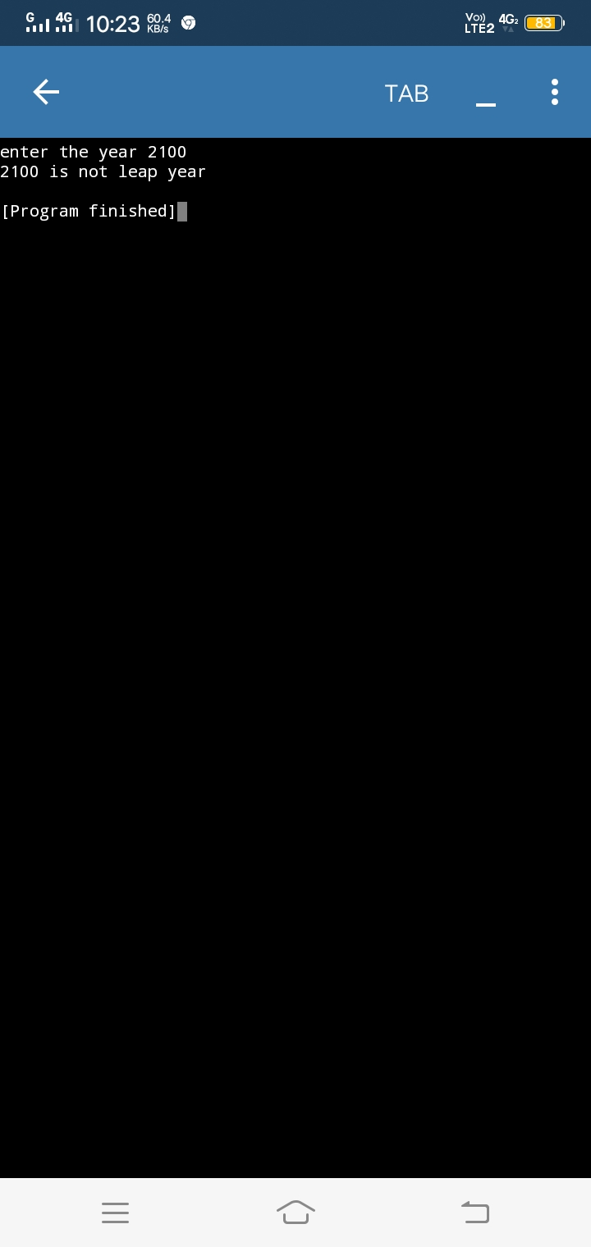

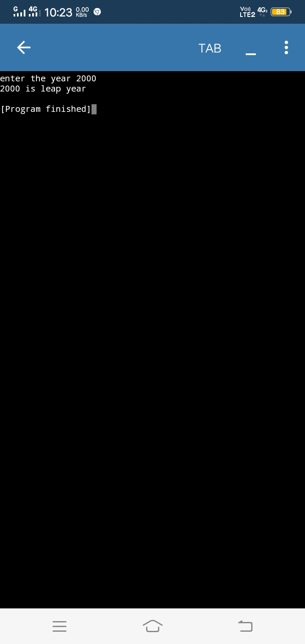**Program 4**

x = int(input("enter a number "))

if x > 0:

print("positive")

elif x < 0:

print("negative")

else:

print("zero")

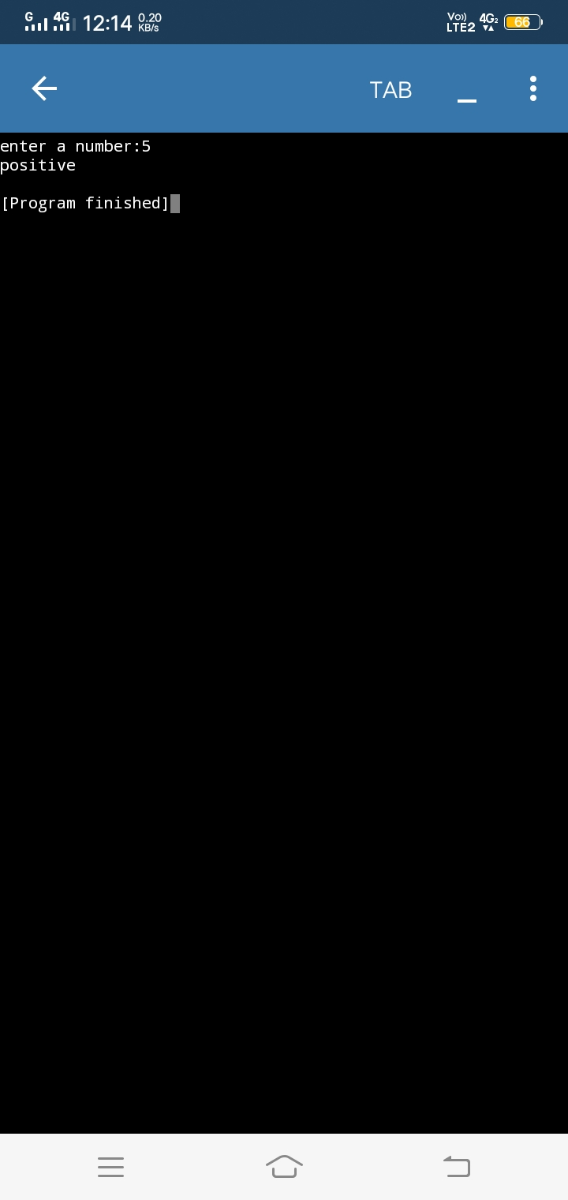

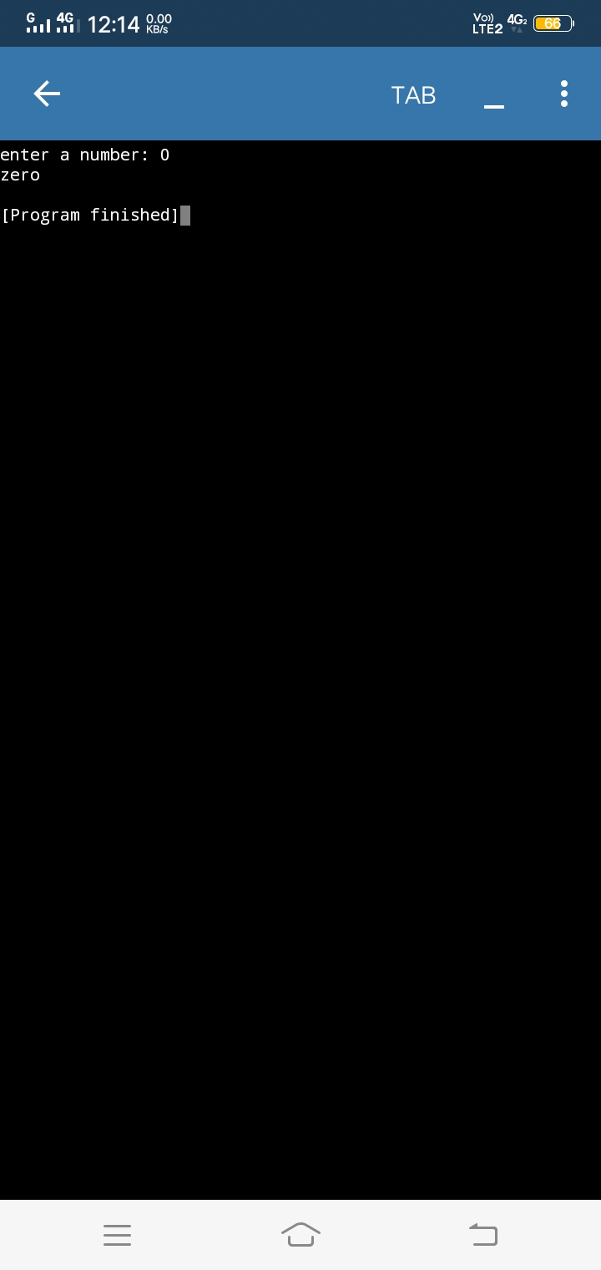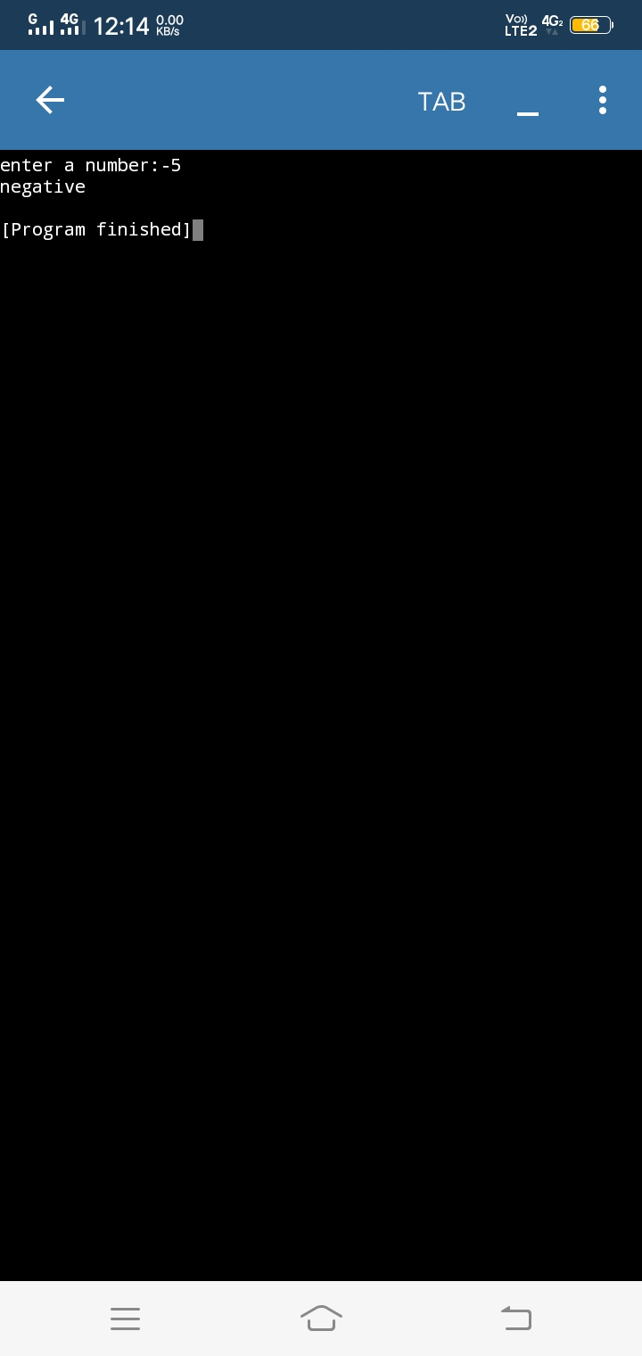**Program 5**

a = int(input("Enter a value"))

b =int(input("Enter b value"))

if a > b:

print("A is greater",a)

else:

print("B is greater",b)

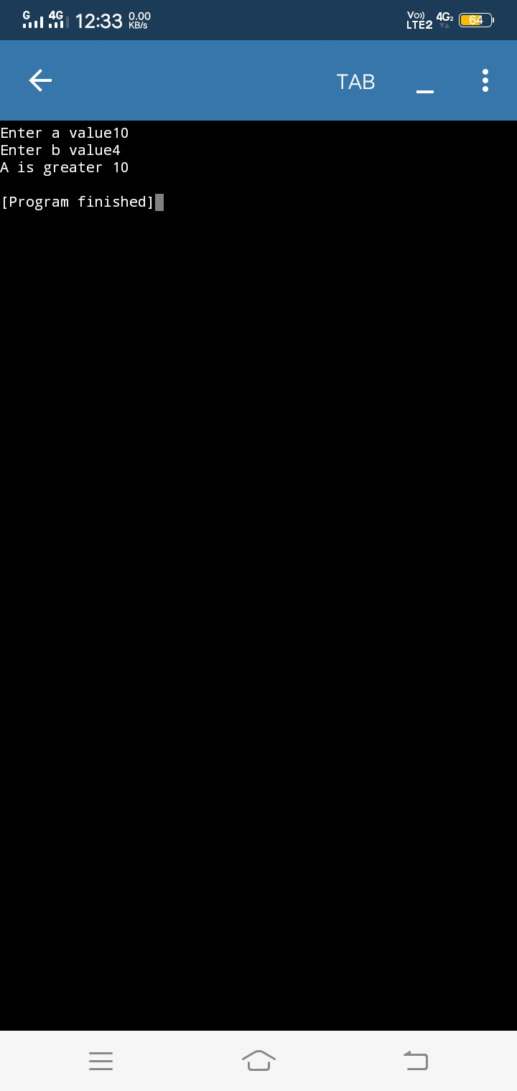

**Program 6**

n = int(input("Enter a value :"))

result = 1

for i in range(n,0,-1):

result = result*i

print("factorial of" ,n," is",result)

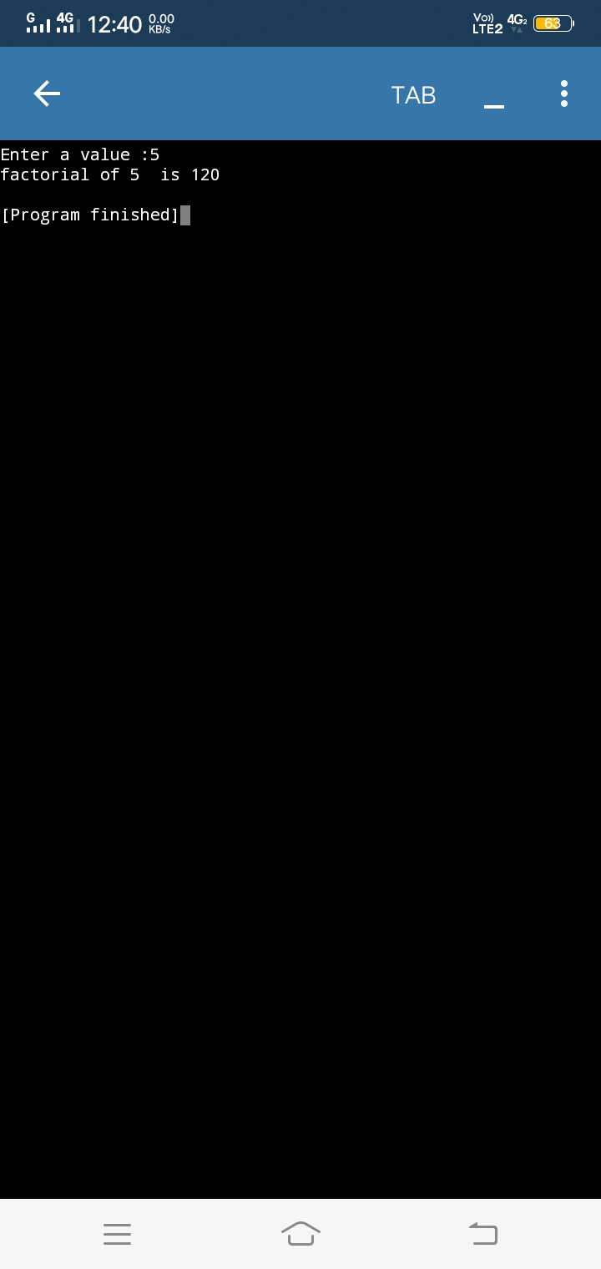

**Program 7**

a = int(input("Enter the value of a "))

b = int(input("Enter the value of b "))

temp = a

a = b

b = temp

print("after swapping")

print("value of a",a)

print("value of b",b)

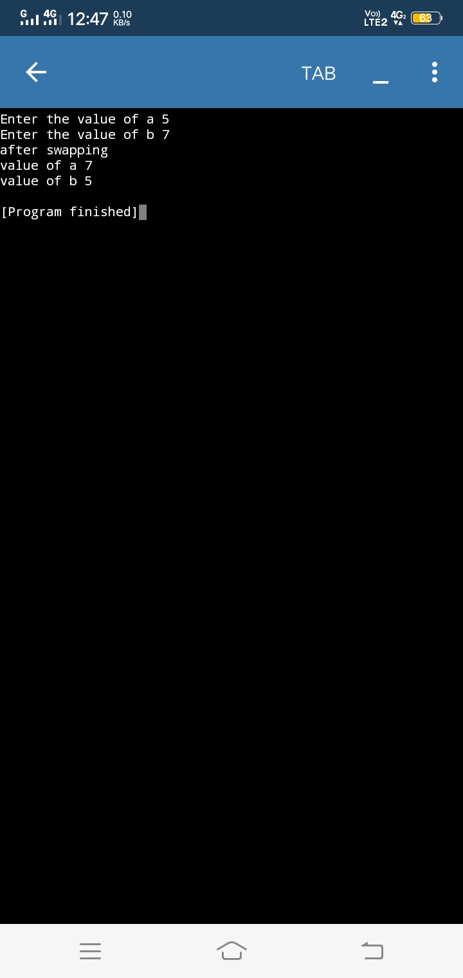

**Program 8**

a=int(input("Enter A value "))

b=int(input("Enter B value"))

if(a<b):

print(a,"A is smaller")

else:

print(b,"B is smaller")

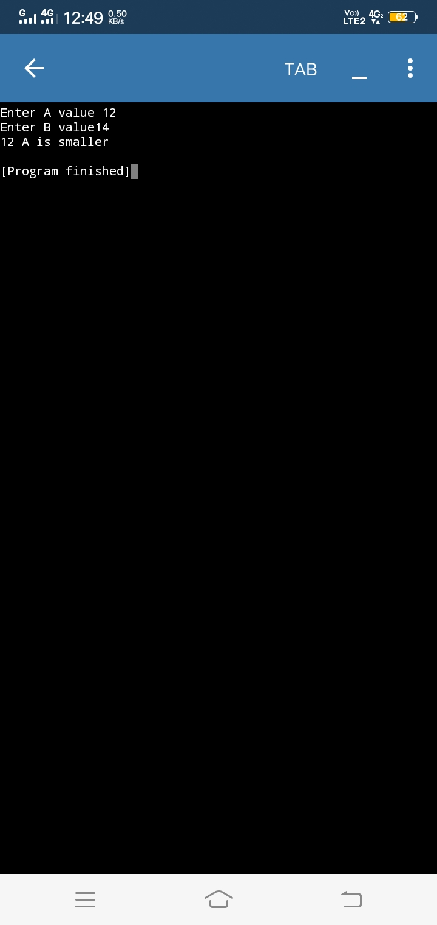

**Program 9**

n1 = int(input("enter a no:"))

if n1<100:

if n1%2==0:

print("the number is even")

else:

print("the number is odd")

else:

print("the number is less than 100")

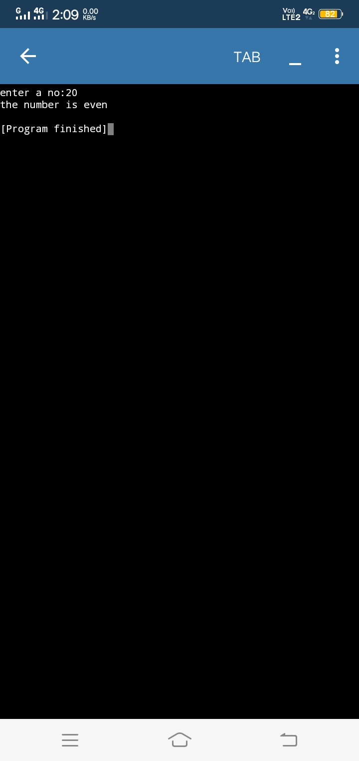

**Program 10**

a = int(input("enter a number"))

while a <=10:

print("square of ",a,"is",a*a)

a =a + 1

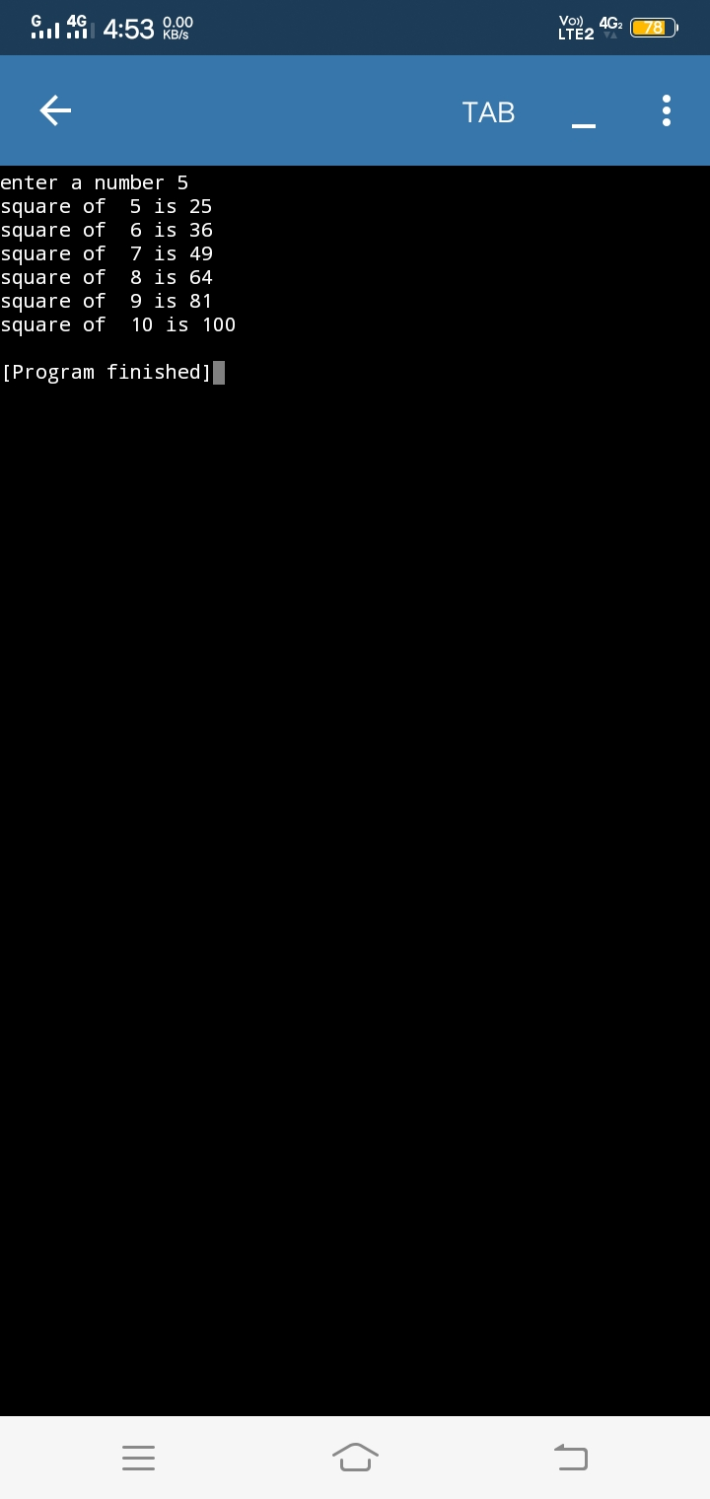

**Program 11**

a = int(input("Enter a number"))

if a >= 0:

if a == 0:

print("zero")

else:

print("a is positive number")

else:

print("a is negative number")

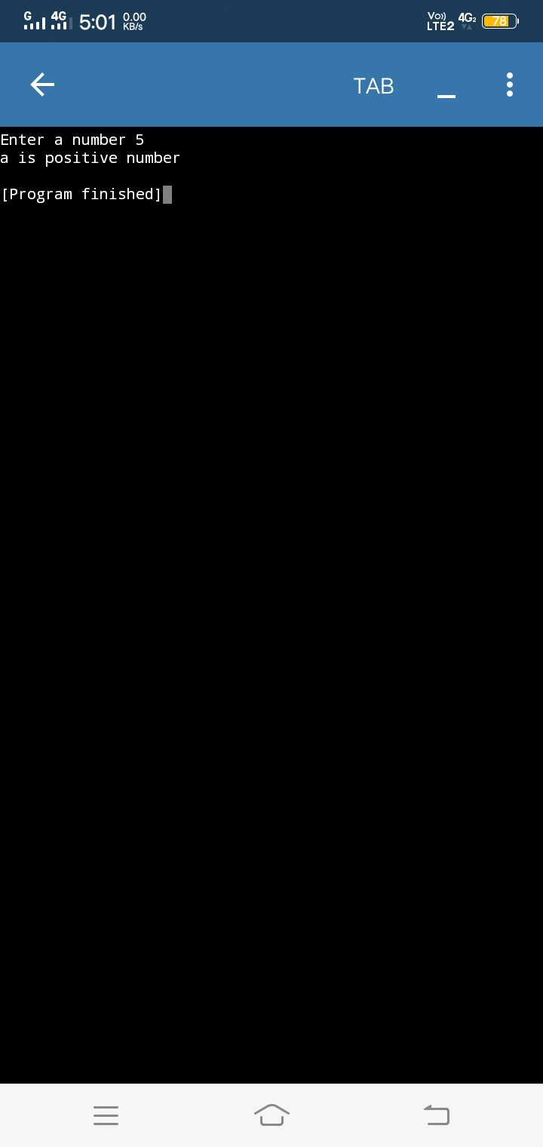

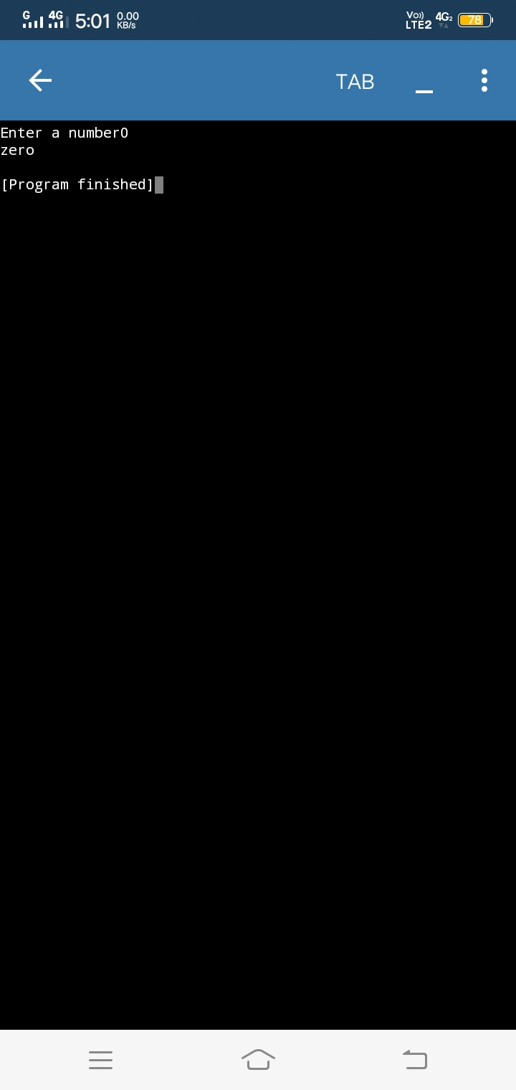

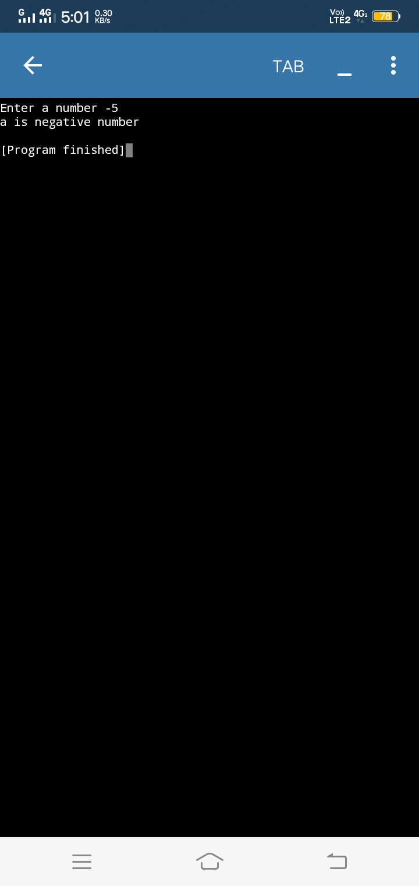

**Program 12**

a=int(input("Enter first number"))

b=int(input("Enter second number"))

c=int(input("Enter third number"))

if a>b:

if a>c:

print("a is the greatest number")

else:

print("c is the greatest number")

if b>c:

print("b is the greatest number")

else:

print("c is the greatest number ")

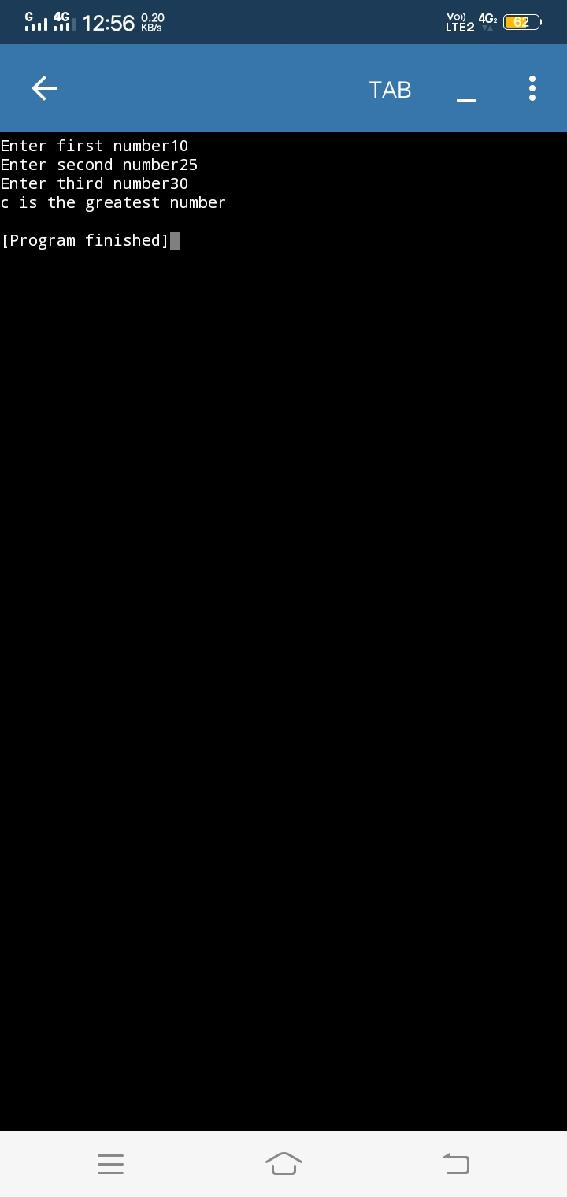

**Program 13**

n1=int(input("Enter 1st number"))

n2=int(input("Enter 2nd number"))

n3=int(input("Enter 3re number"))

if(n1<n2):

if(n1<n3):

print("n1 is the smallest number")

else:

print("n3 is the smallest number")

elif(n2<n3):

print("n2 is the smallest number")

else:

print("n3 is the smallest number")

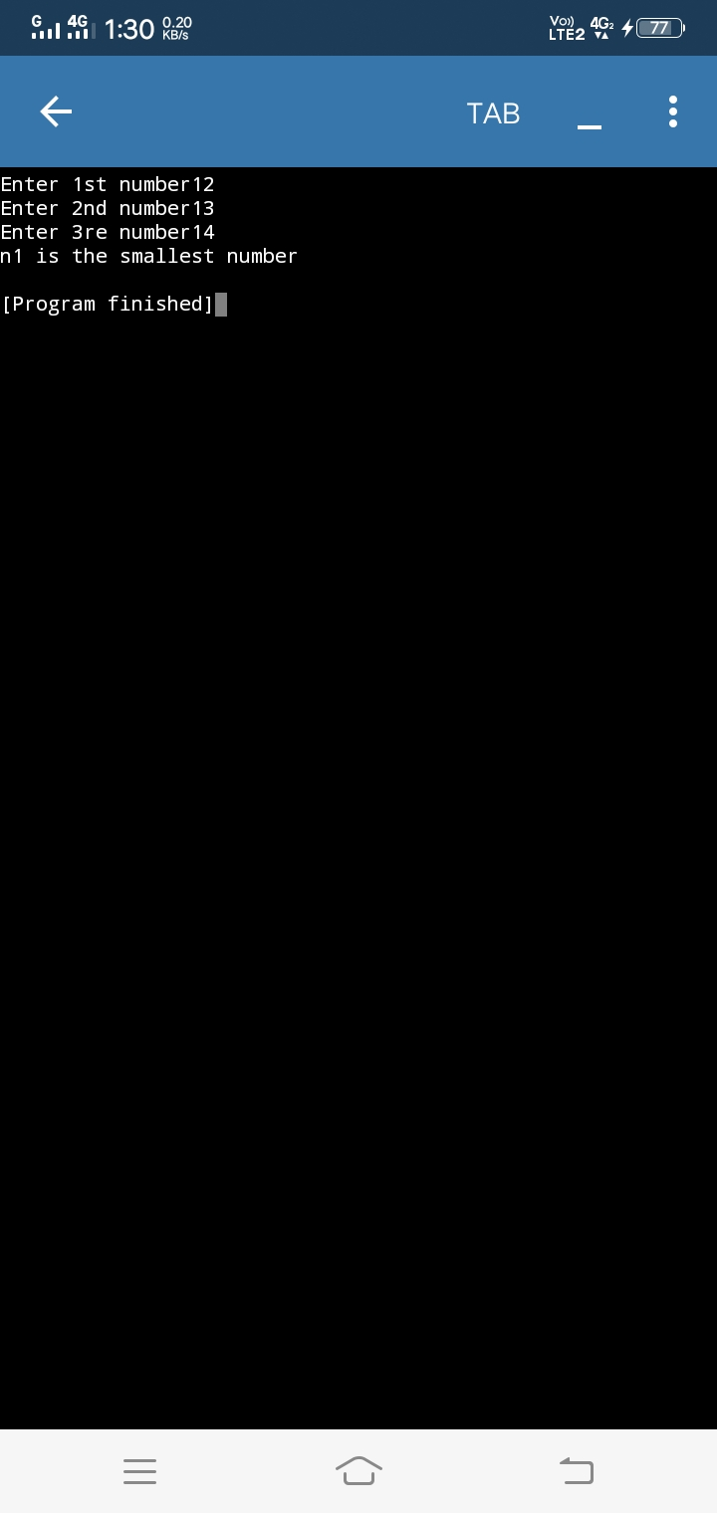

**Program 14**

a = int(input("enter the value of a "))

b = int(input("enter the value of b "))

a = a + b

b = a - b

a = a - b

print("after swapping ")

print("value of a ",a)

print("value of b",b)

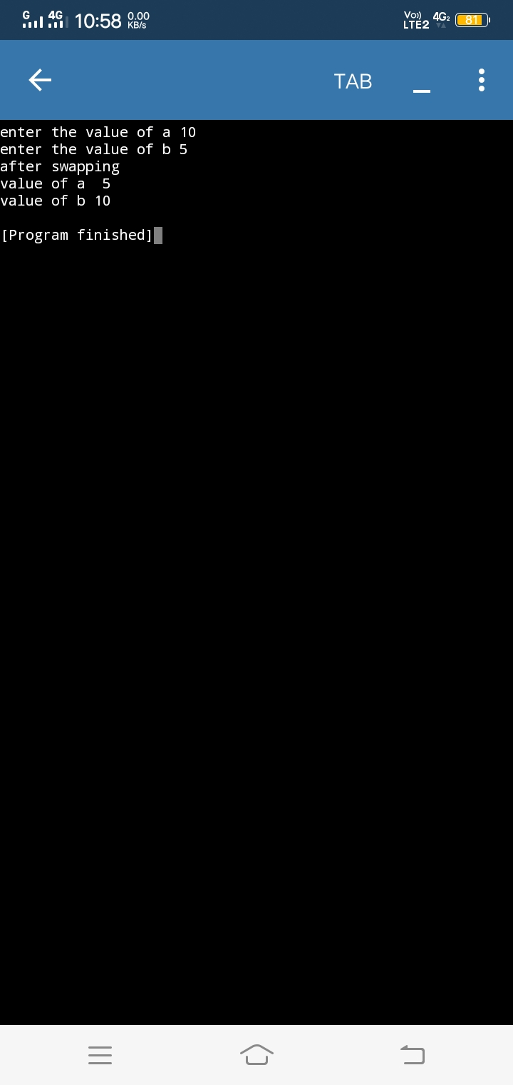

**Program 15**

n1 =int(input("enter the starting number "))

n2=int(input("enter the ending numbe"))

for i in reversed (range(n2,n1+1,3)):

print(i)

n1 =int(input())

n2 =int(input())

while n1>=n2:

print(n1)

n1=n1-3

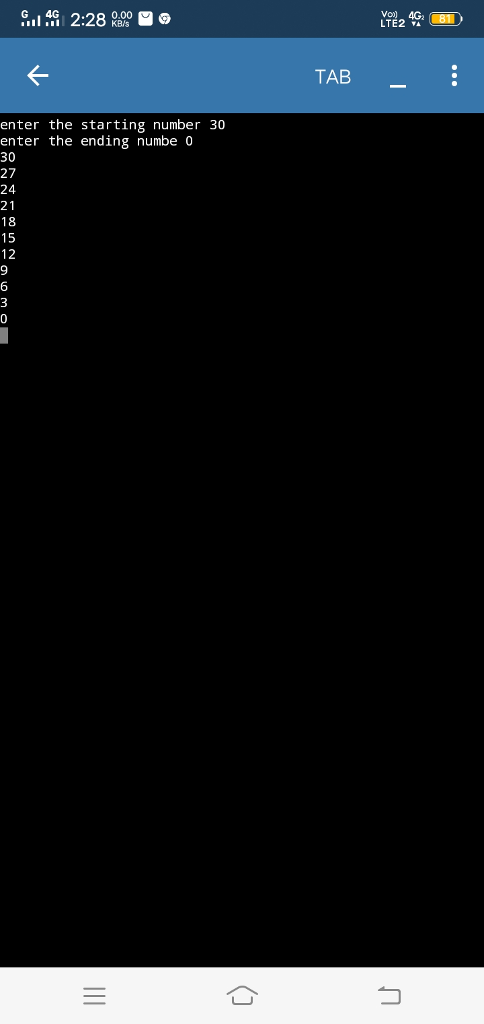 **Index**

|  |  |  |
| --- | --- | --- |
| **Index** | **Task detail** | **Page no** |
| 1 | Create class cal1 that will calculate sum of three numbers.create set data() method which has three parameters that contain numbers.create display() method that will calculate sum and display sum. | 1 to 2 |
| 2 | create class cal2 that will calculate area of a circle.create set data() that should be take radius from the user.create area() method that will calculate area.create display() method that will display area. | 3 to 4 |
| 3 | Create a class cal3 that will calculate simple interest.create constructor method which has three parameters.create callinterest() method that will calculate interest.create display() method that will display interest. | 5 to 6 |
| 4 | Create a class cal4 that will calculate square of number.create set data() method which has one parameter that contain number.create display() method will calculate sum | 7 to 8 |
| 5 | Consider an employee class,which contains fields such as name and designation.and a subclass,which contains a field salary .write a program to inheriting this relation |  |
| 6 | Create a class cal6 that will calculate area of square.create setdata() that should take length from the user.create area() method that will calculate area.create display() method that will display area. |  |
| 7 | Write a program with use of inheritance.define a class publisher that store the name of the title.derive two classes block and tape,which inherit publisher.book class contain member data called page no and tape class contain for playing.define function in the appropriate class to get and print the details. |  |
| 8 | Create a a arith class.the class should be have a parameterized constructor and methods to add,subtract,multiply two numbers and to return the answers. |  |

**Program 1**

class cal1:

def setdata(self,n1,n2,n3):

sum=n1+n2+n3

def display(self,sum):

print("sum is",sum)

fun = cal1()

fun.setdata(12,23,34)

fun.display(69)

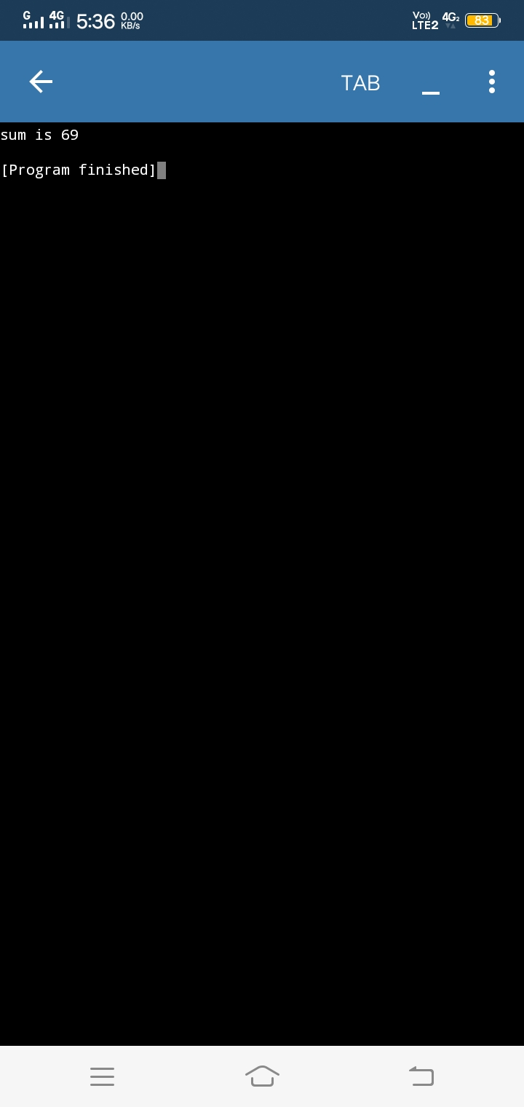

**Program 2**

import math

class cal2:

radius = 0

def setdata(self):

self.radius = float(input("enter the radious of circle "))

def area(self):

self.a = math.pi *(self.radius**2)

def display(self):

print("the area of circle is",self.a)

fun = cal2()

fun.setdata()

fun.area()

fun.display()

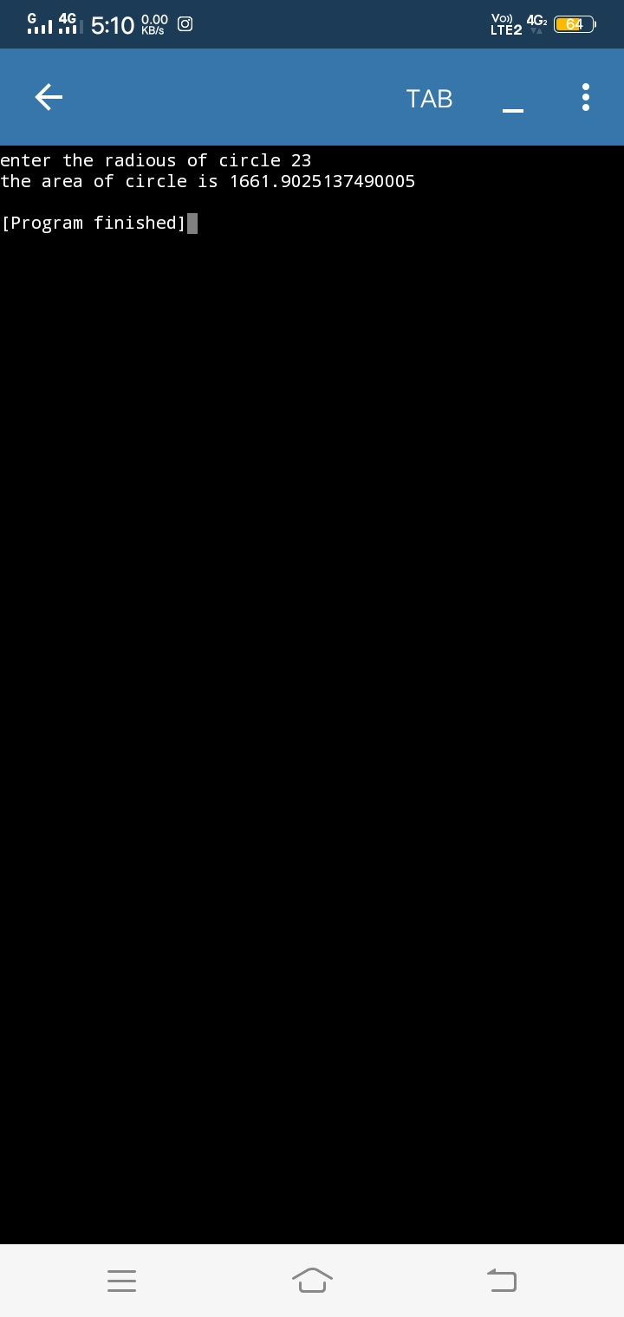

**Program 3**

class cal3:

def _init_(self,p,t,r):

self.p = p

self.t = t

self.r = r

def callinterest(self,p,t,r):

print("The principle is ",p)

print("The time period is",t)

print("The rate of interest is",r)

si = ( p * t * r)/100

def display(self,si):

print("the simple interest is",si)

fun = cal3()

fun.callinterest(8,6,8)

fun.display(3.84)

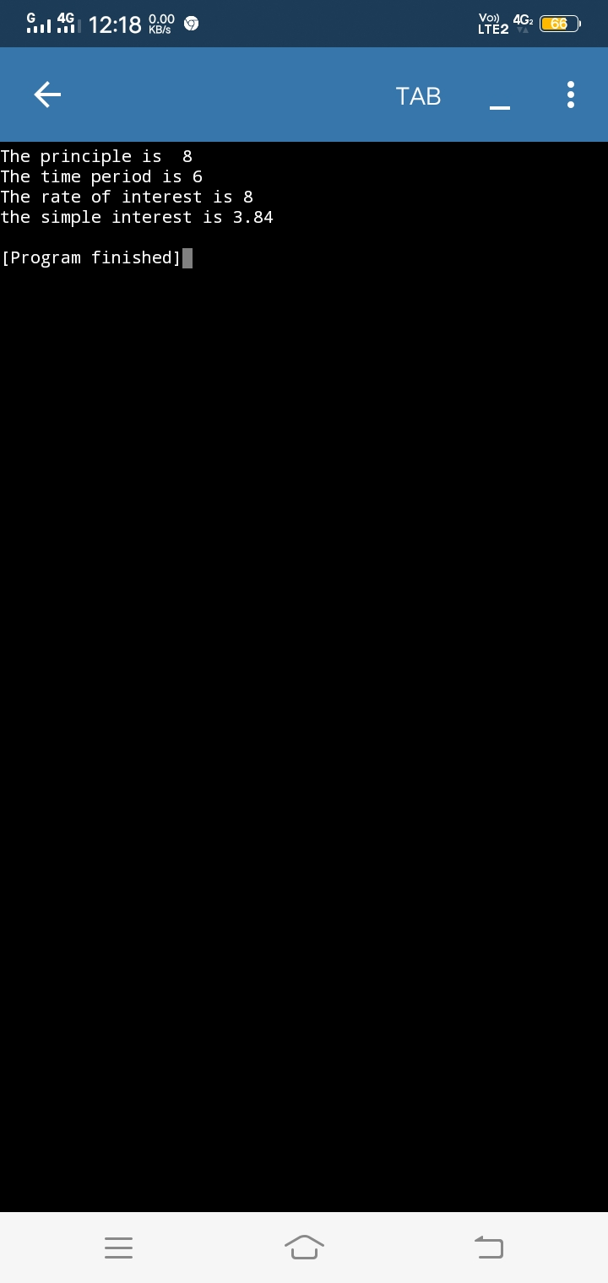

**Program 4**

class cal4:

def setdata(self):

self.n=int(input("enter the number"))

def display(self):

ans = self.n**2

return ans

sum = cal4()

sum.setdata()

print(sum.display())

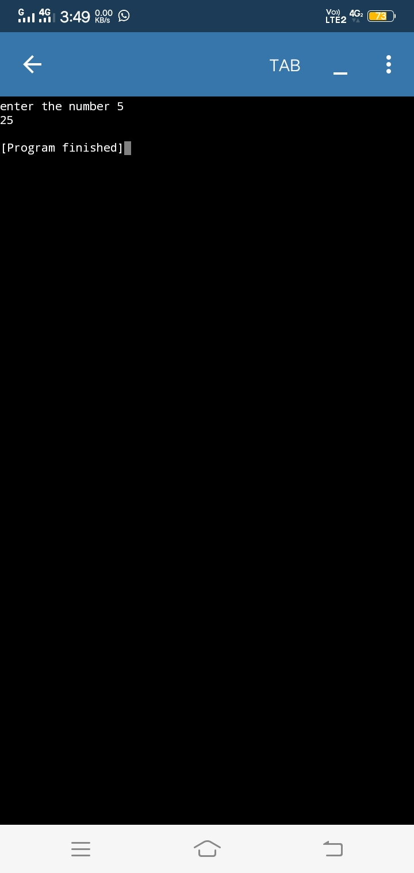

**Program 5**

class employee:

def method1(self,name):

print("Name is ",name)

class employee2:

def method2(self,designation):

print("Designation is",designation)

class employee3(employee,employee2):

def method3(self,salary):

print("Salary is",salary)

e = employee3()

e.method1("Mohan patel")

e.method2("CEO")

e.method3(10000)

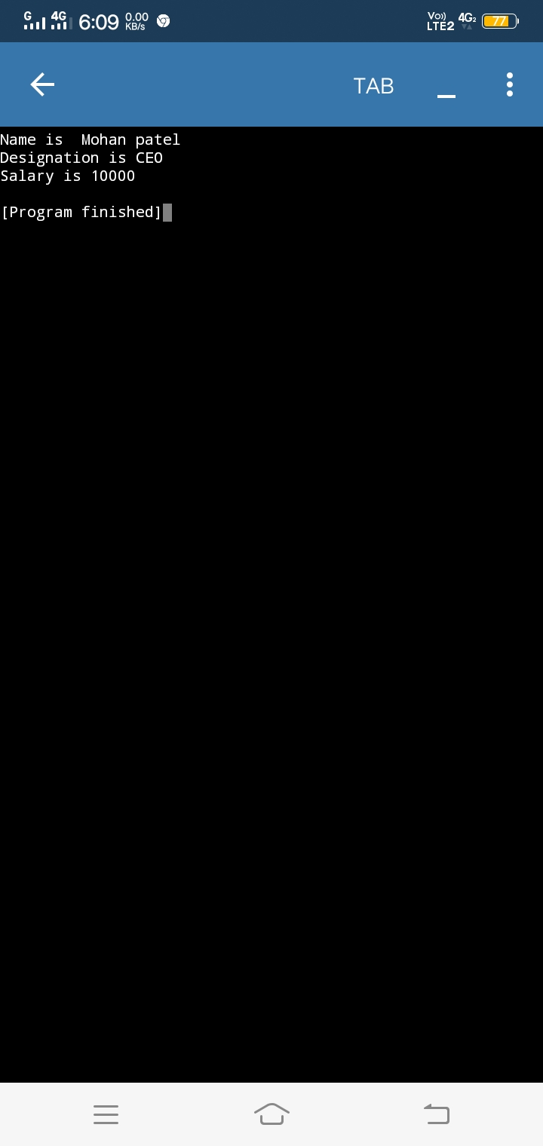

**Program 6**

class cal2:

def setdata(self):

self.l = int(input("enter the length of square"))

def area(self):

self.a = self.l**2

def display(self):

print("the area of square is",self.a)

fun = cal2()

fun.setdata()

fun.area()

fun.display()

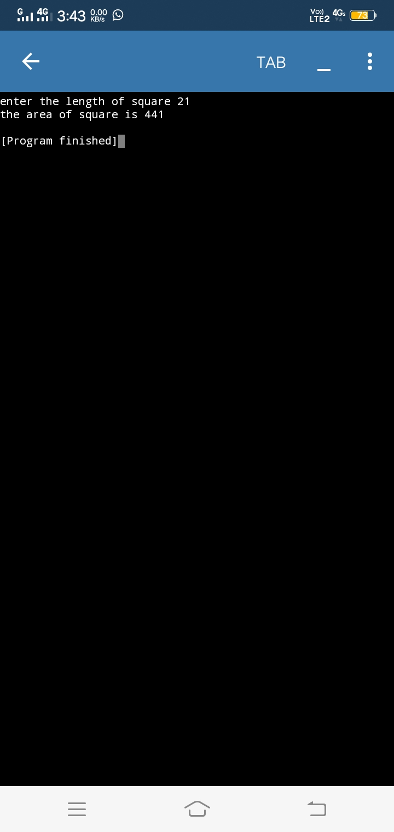

**Program 7**

class publisher :

def name(self,title):

self.title = title

print("the title is",self.title)

class book(publisher):

def data(self,pagenumber):

self.pagenumber = pagenumber

print("the page number is",self.pagenumber)

class type(publisher):

def time(self,time):

self.time = time

print("time is",self.time)

a =book()

b =type()

a.name("this a little")

a.data(14)

b.time(1800)

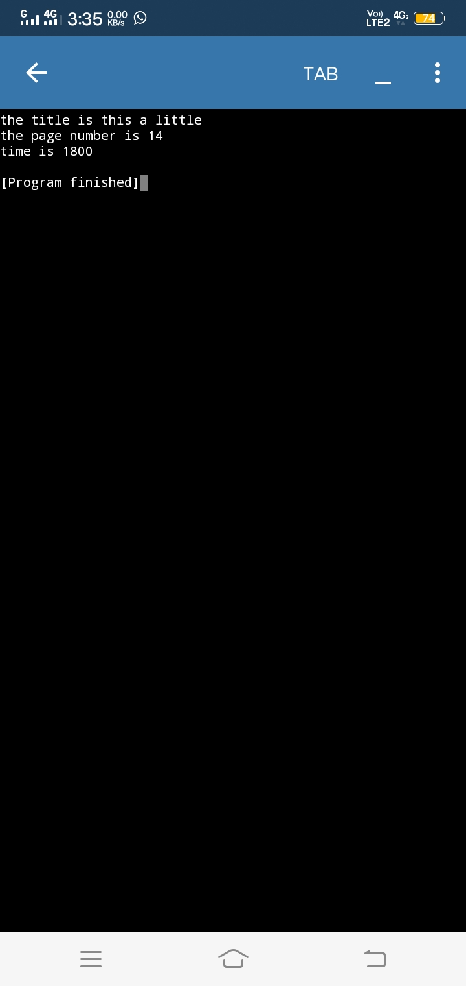**Program 8**

class arith:

def _init_(self,a,b):

self.a = a

self.b =b

def add (a,b):

sum = a+b

sub = a -b

mul = a*b

return sum,sub,mul

def display(self,sum,sub,mul):

print("Addition",sum)

print("Subtraction",sub)

print("Multiply",mul)

x =int(input("enter number"))

y=int(input("enter number"))

ar = arith()

ar.display(15,5,50)

